Handout 2: Sample Floor Plan¹⁰²
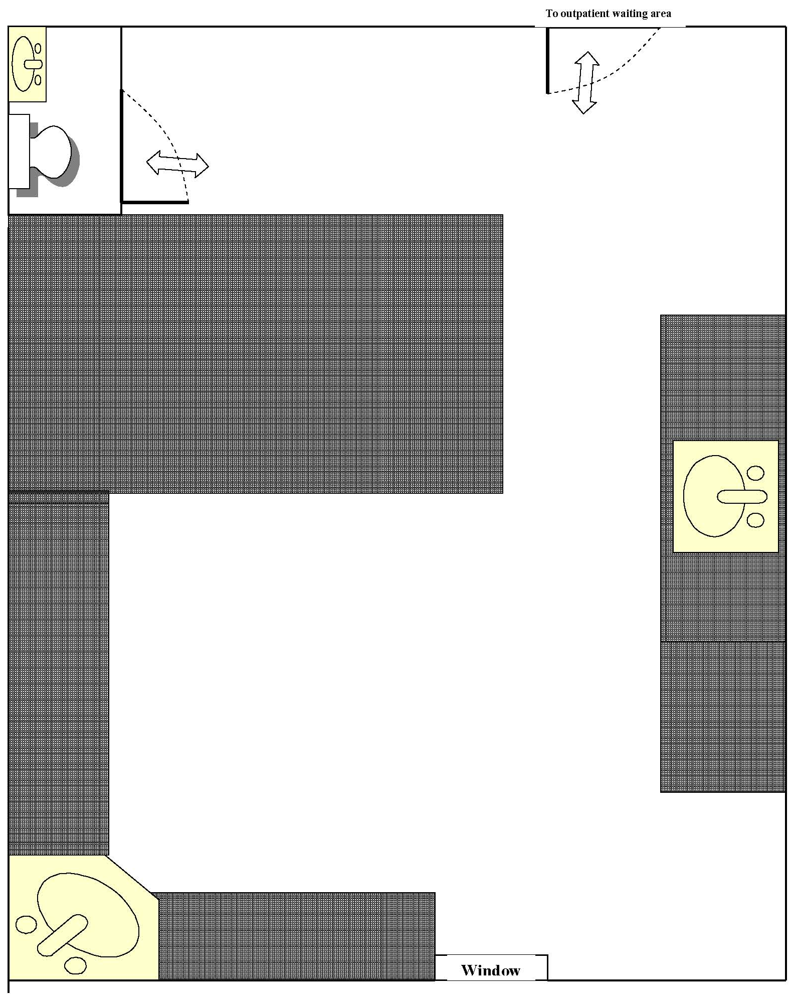
Window

